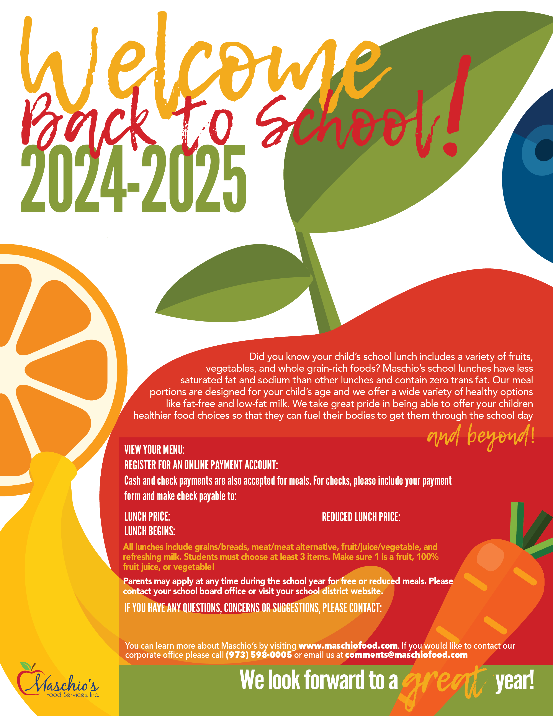

Email Address: mfs209@maschiofood.com

**09/03/24**

Dawn Wyckoff, Food Service Manager

**$3.50**

**Free**

**Frelinghuysen Township School**

**N/A**

https://frelinghuysenschool.nutrislice.com

**Frelinghuysen Township**